|  |  |
| --- | --- |
| **Ebrahim ayman gamal** | **Name**: |
| **Ebrahim195006@feng.bu.edu.eg** | **EDU Email:** |
| **7** | **B.N:** |
| **Database Systems** | **Topic:** |
| ECE001 | **Course code:** |

|  |  |
| --- | --- |
|  | **The Link** |
|  | **GitHub-page (published website)** |

**Before we learn a DBMS, let's understand-What is a Database?**

**A database is a collection of related data which represents some aspect of the real world. A database system is designed to be built and populated with data for a certain task.**

# **DBMS**

**Database Management System (DBMS) is a software for storing and retrieving users' data while considering appropriate security measures. It is composed of a group of programs that manipulate the database. The DBMS acknowledges an application 's request for data, and instructs the operating system to provide similar data. A DBMS allows users and other third-party applications to store and retrieve data in large systems. DBMS enables users to build their own databases, as needed. The word "DBMS" involves the database user as well as other application programs. It offers an interface between the software application and the data.**

# **Structured Query Language (SQL)**

**SQL is a programming language used to query, modify, and describe data for almost all relational databases and to provide access control. SQL was first developed with Oracle as a major contributor at IBM in the 1970s, leading to the implementation of the SQL ANSI standard, and SQL has spurred many extensions from companies such as IBM, Oracle, and Microsoft. Though SQL is still widely used today, the appearance of new programming languages is beginning.**

# **Evolution of the Database**

**Since their emergence in the early 1960s the databases have grown dramatically. The original systems used to store and manage data were navigational databases such as the hierarchical database (which relied on a tree-like model and permitted only one-to-many relationships), and the network database (a more** **versatile model that allowed multiple relationships). Those early systems were inflexible though simple. Relational databases became popular during the 1980s, followed by object-oriented databases in the 1990s. Recently NoSQL databases have emerged as a response to internet growth and the need for faster speed and unstructured data processing. Cloud databases and self-driving systems today break new ground when it comes to how data is collected, stored, handled and used.**

**Figure** **1**

# **the Difference Between a Database and a Spreadsheet**

**Databases and spreadsheets (such as Microsoft Excel) are both convenient ways to store information. The primary differences between the two are:**

**⃰ How the data is stored and manipulated?**

**Figure 2**

**⃰ Who can access the data?**

**⃰ How much data can be stored?**

**Originally, spreadsheets were designed for one user, and their properties reflect that. They 're great for a single user or a small number of users who don't need to manipulate a lot of unbelievably complicated data. At the other hand, databases are built to contain much larger quantities of structured information sometimes, vast volumes. Databases allow multiple users to access and query the data quickly and securely using highly complex logic and language at the same time.**

# **Types of Databases**

**There are many different types of databases. The best database for a specific organization depends on how the organization intends to use the data.**

|  |  |
| --- | --- |
| **Type of Database** | **Description** |
| **Relational databases** | **Relational databases became dominant in the 1980s. Items in a relational database are organized as a set of tables with columns and rows. Relational database technology provides the most efficient and flexible way to access structured information.** |
| **Object-oriented databases** | **Information in an object-oriented database is represented in the form of objects, as in object-oriented programming.** |
| **Distributed databases.** | **A distributed database consists of two or more files located in different sites. The database may be stored on multiple computers, located in the same physical location, or scattered over different networks.** |
| **Data warehouses** | **A central repository for data, a data warehouse is a type of database specifically designed for fast query and analysis.** |
| **NoSQL databases** | **A NoSQL, or nonrelational database, allows unstructured and semi structured data to be stored and manipulated (in contrast to a relational database, which defines how all data inserted into the database must be composed). NoSQL databases grew popular as web applications became more common and more complex.** |
| **Graph databases** | **A graph database stores data in terms of entities and the relationships between entities.** |
| **OLTP databases** | **An OLTP database is a speedy, analytic database designed for large numbers of transactions performed by multiple users.** |
| **Open source databases** | **An open source database system is one whose source code is open source; such databases could be SQL or NoSQL databases.** |
| **Cloud databases** | **A cloud database is a collection of data, either structured or unstructured, that resides on a private, public, or hybrid cloud computing platform. There are two types of cloud database models: traditional and database as a service (DBaaS). With DBaaS, administrative tasks and maintenance are performed by a service provider.** |
| **Multimodal database** | **Multimodel databases combine different types of database models into a single, integrated back end. This means they can accommodate various data types.** |
| **Document/JSON database** | **Designed for storing, retrieving, and managing document-oriented information, document databases are a modern way to store data in JSON format rather than rows and columns.** |
| **Self-driving databases** | **The newest and most groundbreaking type of database, self-driving databases (also known as autonomous databases) are cloud-based and use machine learning to automate database tuning, security, backups, updates, and other routine management tasks traditionally performed by database administrators.** |

**These are only a few of the several hundred database forms that are in use today.**

**Other, less popular databases are customized to particular roles of research, finance, or other matters. In addition to the various types of databases, improvements in approaches to technology growth and rapid advancements like the cloud and automation are propelling databases in radically new directions. Some of the latest databases are available.**

# **Characteristics of Database Management System**

1. **Provides security and removes redundancy**
2. **Self-describing nature of a database system**
3. **Insulation between programs and data abstraction**
4. **Support of multiple views of the data**
5. **Sharing of data and multiuser transaction processing**
6. **DBMS allows entities and relations among them to form tables.**
7. **It follows the ACID concept (Atomicity, Consistency, Isolation, and Durability).**
8. **DBMS supports multi-user environment that allows users to access and manipulate data in parallel.**

# **Dis/advantages of DBMS**

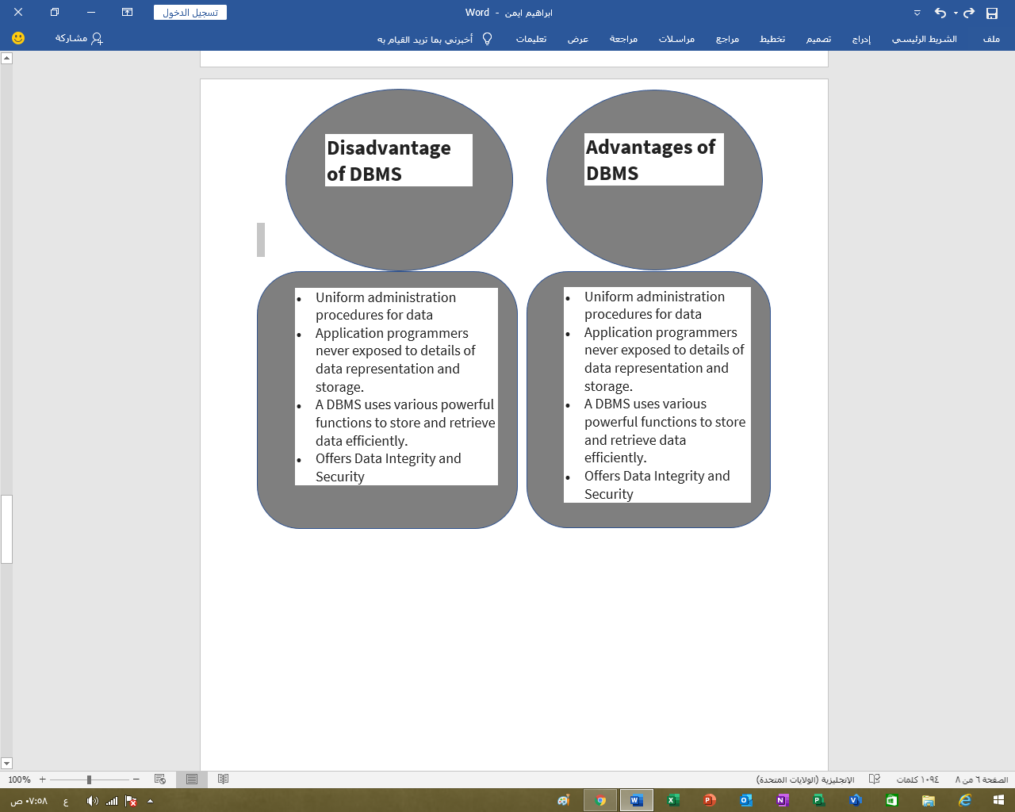

# **Database Challenges**

**The massive corporate databases of today also support very complex queries and are supposed to provide near-instant answers to those queries. Database managers are therefore increasingly called upon to use a wide range of methods to help boost performance. Some rising obstacles facing them include:**

**Absorbing significant increases in volume of data. The flood of data from sensors, connected computers, and hundreds of other sources leaves database administrators struggling to effectively handle and coordinate the data from their businesses. Ensuring data security. These days, data breaches happen everywhere and hackers are getting more creative. Being sure that the data is safe but still readily available to users is more critical than ever. Sticking to demand. In today's fast-moving market climate, businesses need access to their data in real time to help timely decision-making and identify new opportunities. Managing and maintaining the database and infrastructure. Database administrators must monitor the database for issues on an ongoing basis and conduct preventive maintenance and apply software updates and patches. As databases become more complex and volumes of data expand, businesses face the cost of recruiting additional expertise to track and tuning their databases. Removing limits on scalability. If it is going to thrive, a company needs to develop and its data management needs to grow along with it. But it's very hard for database administrators to foresee how much capacity the company will need, particularly for on-premises databases.**

# **When not to use a DBMS system?**

**Although, DBMS system is useful. It is still not suited for specific task mentioned below: Not recommended when you do not have the budget or the expertise to operate a DBMS. In such cases, Excel/CSV/Flat Files could do just fine.**

**Reference:**

**1-** (Oracle, n.d.)

**2-** ( Guru99 , n.d.)

# **Screenshot from my website:**

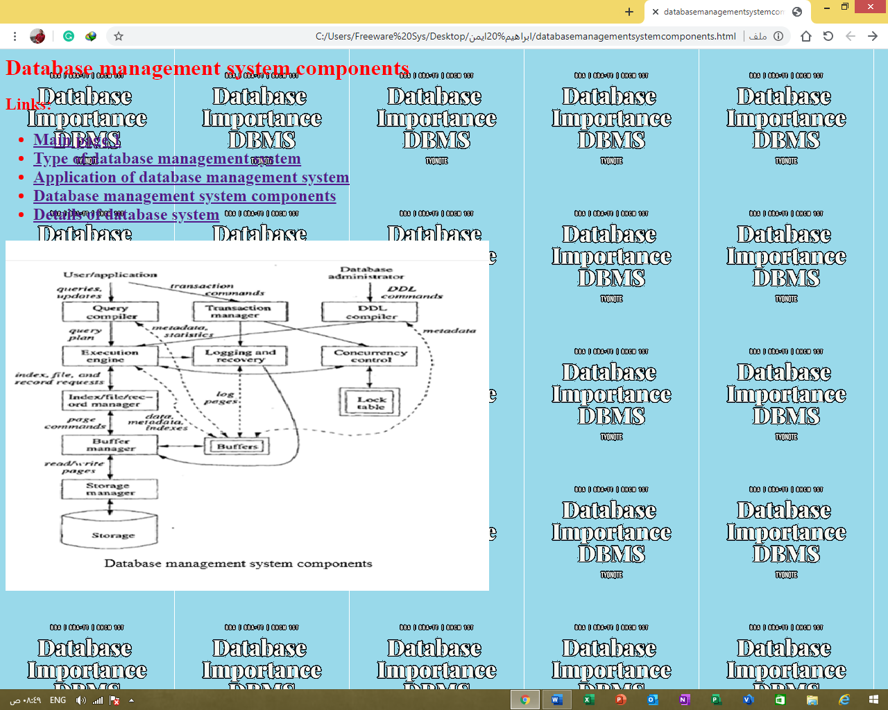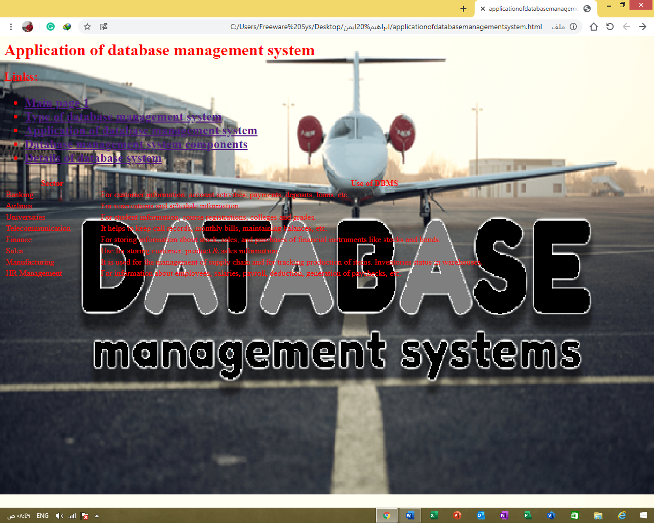

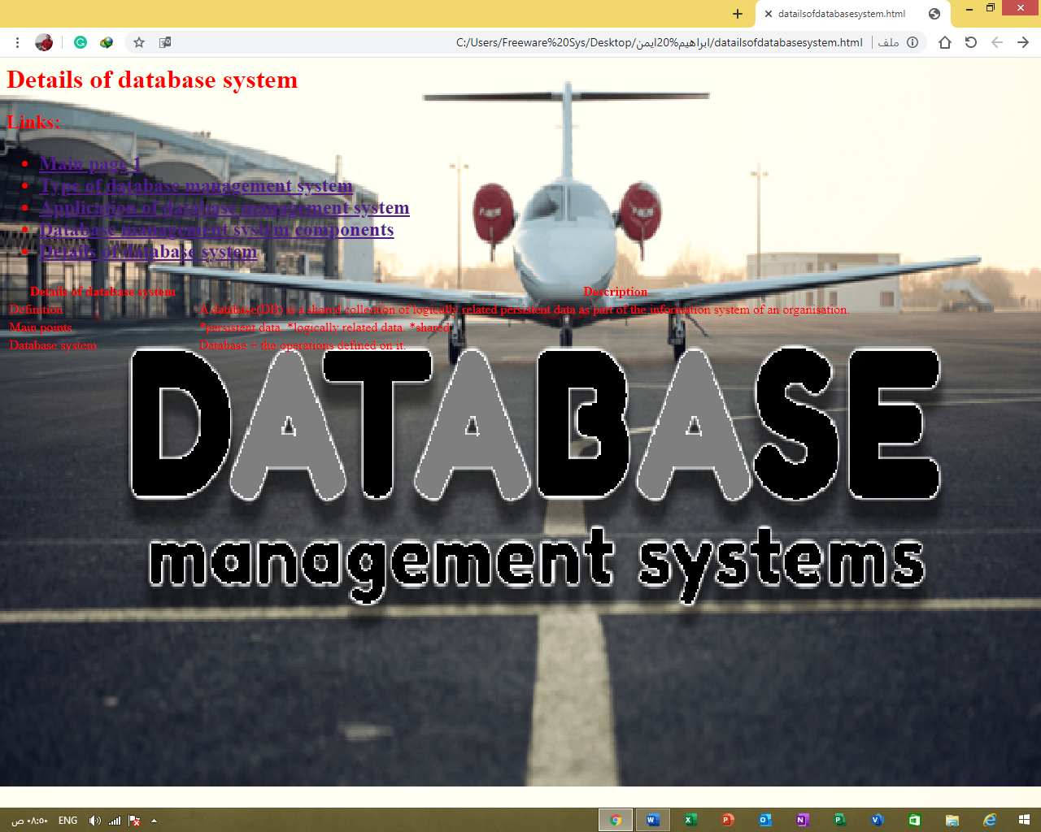

# **Source Code from my pages:**

